**Use Case Overview**

**Use Case Diagram Level 0:** Report

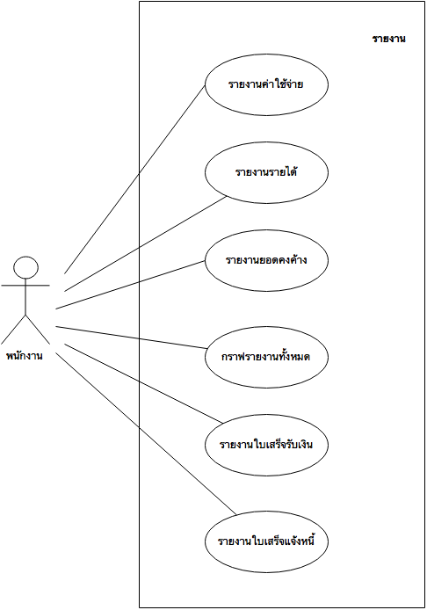

**Use Case Diagram Level 1:** Earnings reports

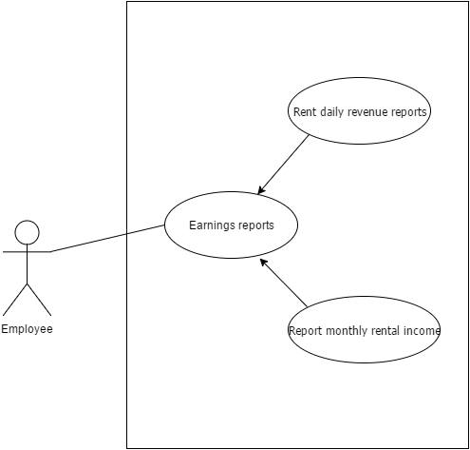

**Use Case Diagram Level 1:** Expenditure report

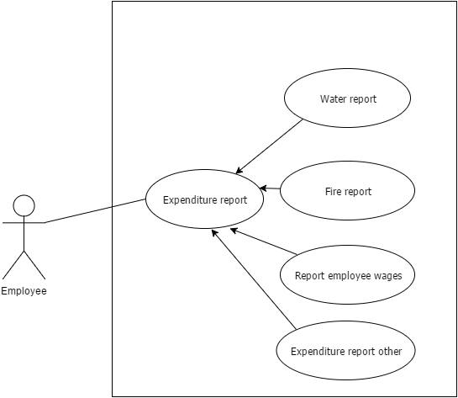

**Use Case Diagram Level 1:** Report graph

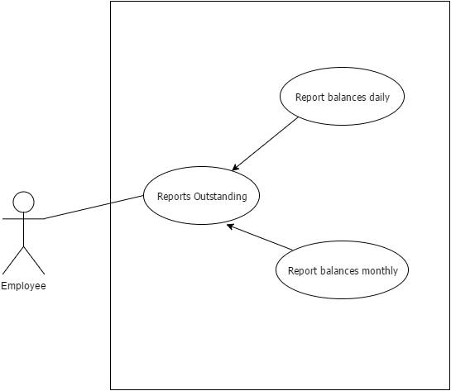

**Use Case Diagram Level 1:** Report outstanding

